### Practical File

### Of

### Problem Solving using Python Programming

### 23CS001

#### Submitted

#### in partial fulfillment for the award of the degree of

## BACHELEOR OF ENGINEERING

***in***

COMPUTER SCIENCE & ENGINEERING



**CHITKARA UNIVERSITY**

**CHANDIGARH-PATIALA NATIONAL HIGHWAY**

**RAJPURA (PATIALA) PUNJAB-140401 (INDIA)**

##### December, 2023

##### **Submitted To: Dr Garima**

##### **Submitted By : Sahiba Saini**

##### **(2310992514)**

##### **(Group no.:29)**

Faculty name : Dr Garima

|  |  |  |
| --- | --- | --- |
| **Sr. No.** | **Practical Name** | **Teacher Sign** |
| 1 | a) Write a [Python Program to Calculate the Area of a Triangle](https://www.programiz.com/python-programming/examples/area-triangle)  b) Write a [Python Program to Swap Two Variables](https://www.programiz.com/python-programming/examples/swap-variables)  c) Write a [Python Program to Convert Celsius to Fahrenheit](https://www.programiz.com/python-programming/examples/celsius-fahrenheit) |  |
| 2 | a.) Write a [Python Program to Check if a Number is Odd or Even](https://www.programiz.com/python-programming/examples/odd-even)  b.) Write a [Python Program to Check if a Number is Positive, Negative or 0](https://www.programiz.com/python-programming/examples/positive-negative-zero)  c.) Write a [Python Program to Check Armstrong Number](https://www.programiz.com/python-programming/examples/armstrong-number) |  |
| 3 | a.) Write a Python program to check if a given number is Fibonacci number?  b.) Write a Python program to print cube sum of first n natural numbers.  c.) Write a Python program to print all odd numbers in a range. |  |
| 4 | a.) Write a Python Program to Print Pascal Triangle  Hint: Enter number of rows: 4  1  1 1  1 2 1  1 3 3 1  b.) WAP to Draw the following Pattern for n number:  1 1 1 1 1  2 2 2 2  3 3 3  4 4  5 |  |
| 5 | Write a program with a function that accepts a string from keyboard and create a new string after converting character of each word capitalized. For instance, if the sentence is “stop and smell the roses” the output should be “Stop And Smell The Roses” |  |
| 6 | a.) Write a program that accepts a list from user. Your program should reverse the content of list and display it. Do not use reverse () method.  b)  Find and display the largest number of a list without using built-in function  max (). Your program should ask the user to input values in list from keyboard. |  |
| 7 | Find the sum of each row of matrix of size m x n. For example, for the following matrix output will be like this:    Sum of row 1 = 32  Sum of row 2 = 31  Sum of row 3 = 63 |  |

|  |  |
| --- | --- |
| 1. | a) Write a [Python Program to Calculate the Area of a Triangle](https://www.programiz.com/python-programming/examples/area-triangle)  b) Write a [Python Program to Swap Two Variables](https://www.programiz.com/python-programming/examples/swap-variables)  c) Write a [Python Program to Convert Celsius to Fahrenheit](https://www.programiz.com/python-programming/examples/celsius-fahrenheit) |

**Solution**: a) base=int(input(“Enter a no.”))

hyt=int(input(“Enter a no.”))

area=0.5*base*hyt

print(“Area of Triangle”,area)

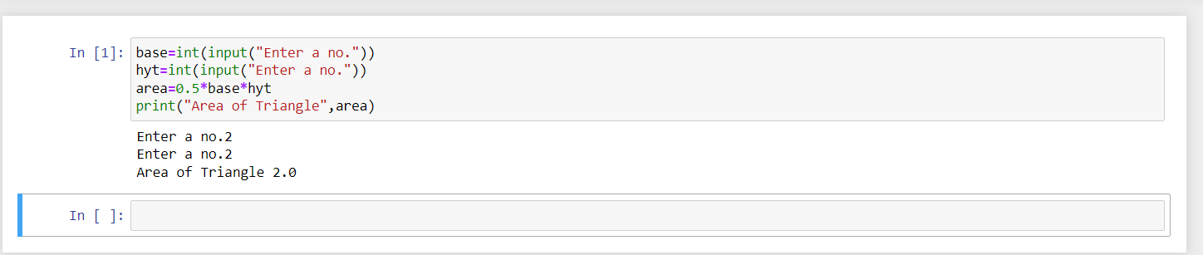

b) x = int(input())

y = int(input())

x , y = y , x

print("value after swapping:",x)

print("value after swapping:",y)

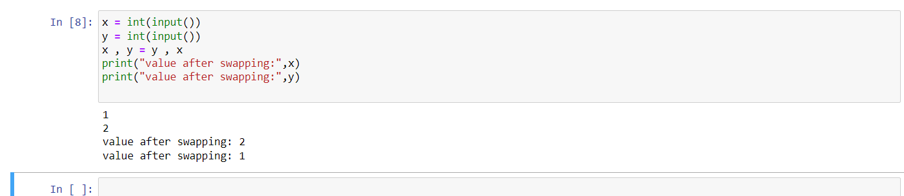

c) c=int(input())

f=(c*1.8)+32

print(f)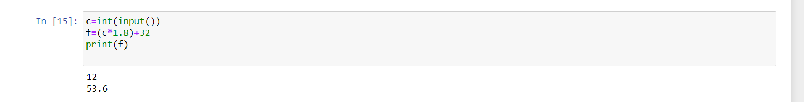

|  |  |
| --- | --- |
| 2. | a.) Write a [Python Program to Check if a Number is Odd or Even](https://www.programiz.com/python-programming/examples/odd-even)  b.) Write a [Python Program to Check if a Number is Positive, Negative or 0](https://www.programiz.com/python-programming/examples/positive-negative-zero)  c.) Write a [Python Program to Check Armstrong Number](https://www.programiz.com/python-programming/examples/armstrong-number) |

Solution: a) n = int(input(“Enter a no.”))

if n%2==0:

print(“even no.”)

else:

print(“odd no.”)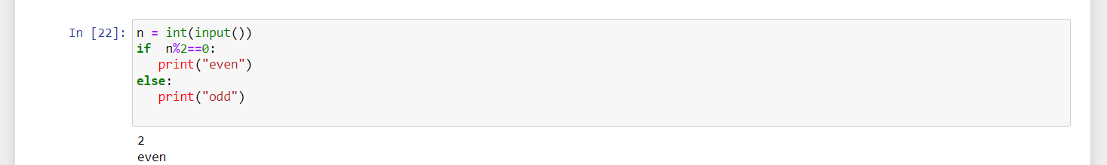

b) n=int(input(“Enter a no.”))

if n>0:

print(“positive no.”)

elif n<0:

print(“negative no.”)

else:

print(“Zero”)

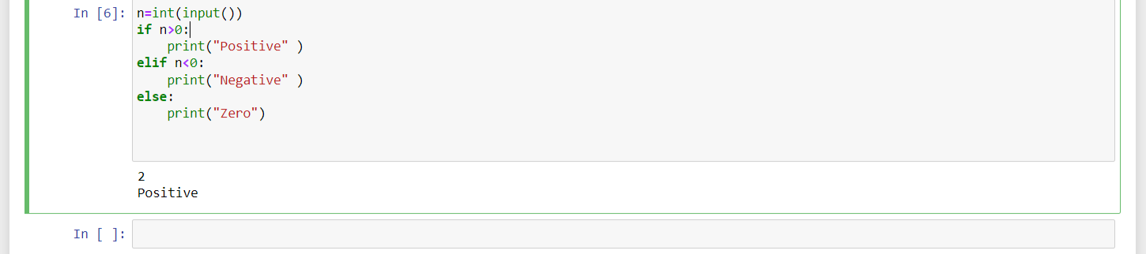

c) num=int(input(“Enter a no.”))

sum=0

temp=num

while temp>0:

digit=temp%10

sum+=digit**3

temp//=10

if num==sum:

print(num,”is an Armstrong no.”)

else:

print(num,”not an Armstrong no.”)

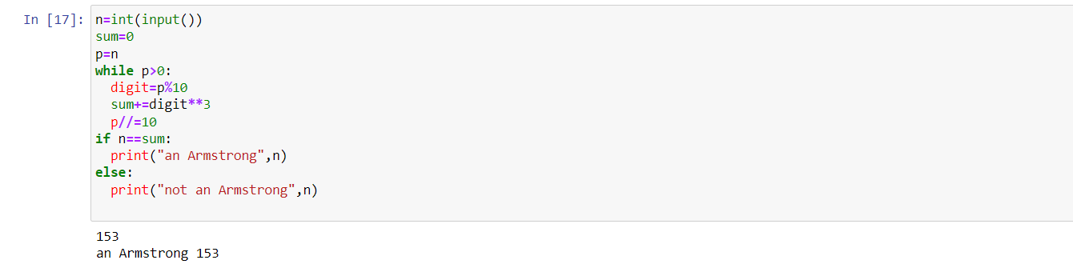

|  |  |
| --- | --- |
| 3. | a.) Write a Python program to check if a given number is Fibonacci number?  b.) Write a Python program to print cube sum of first n natural numbers.  c.) Write a Python program to print all odd numbers in a range. |

Solution: a) n=int(input(“Enter a no.”))

c=0

a=1

b=1

if n==0 or n==1:

print(“Yes”)

else:

while c<n:

c=a+b

b=a

a=c

if c==n:

print(“Yes”)

else:

print(“No”)

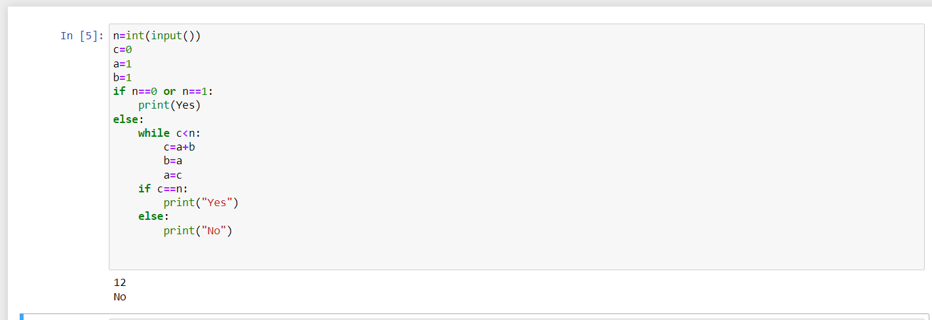

b) n=int(input(“Enter a no.”))

x=(n*(n+1)/2)**2

print(“The sum of series is “,x)

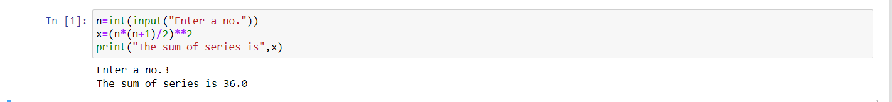

c) st=int(input(“Enter a no.”))

end=int(input("Enter a no."))

for num in range (st,end+1):

if num%2!=0:

print(num,end=" ")

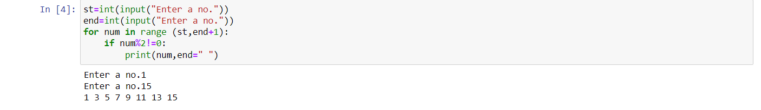

|  |  |
| --- | --- |
| 4. | a.) Write a Python Program to Print Pascal Triangle  Hint: Enter number of rows: 4  1  1 1  1 2 1  1 3 3 1  b.) WAP to Draw the following Pattern for n number:  1 1 1 1 1  2 2 2 2  3 3 3  4 4  5 |

Solution: a) from math import factorial

n=int(input())

for i in range(n):

for j in range(n-i+1):

print(end=" ")

for j in range(i+1):

print(factorial(i)//(factorial(j)*factorial(i-j)), end=" ")

print()

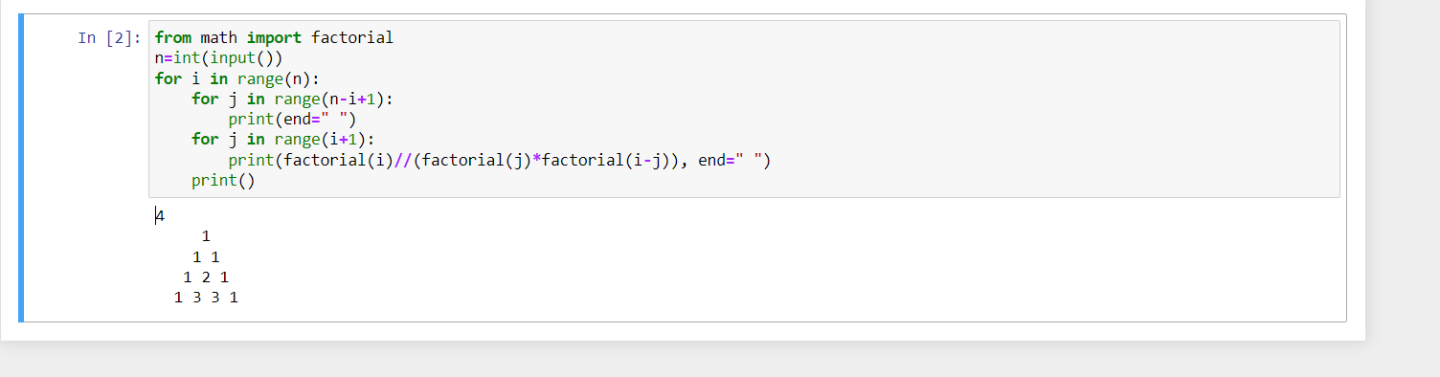

b). rows=int(input())

for i in range(1,rows+1):

for j in range(rows-i+1):

print(i,end=" ")

print() 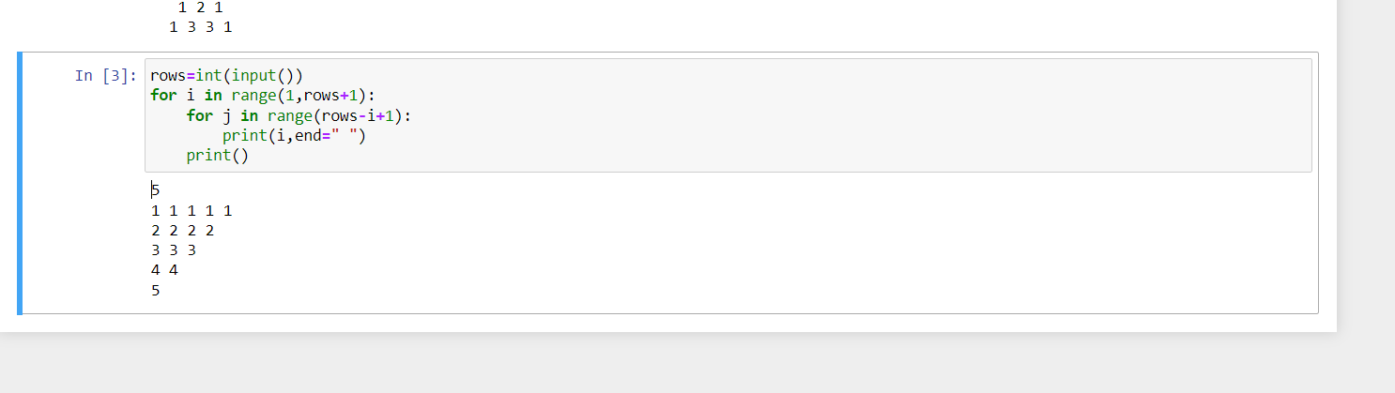

|  |  |
| --- | --- |
| 5. | Write a program with a function that accepts a string from keyboard and create a new string after converting character of each word capitalized. For instance, if the sentence is “stop and smell the roses” the output should be “Stop And Smell The Roses” |

Solution: str=input()

a=0

a=str.split()

string2=" "

for i in a:

c=i.capitalize()

string2+=c+" "

print(string2)

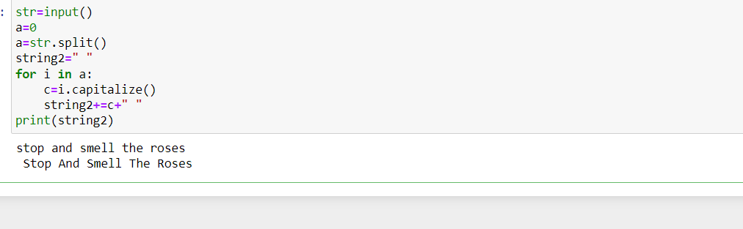

|  |  |
| --- | --- |
| 6. | a.) Write a program that accepts a list from user. Your program should reverse the content of list and display it. Do not use reverse () method.  b)  Find and display the largest number of a list without using built-in function  max (). Your program should ask the user to input values in list from keyboard. |

Solution: a). list1=[]

non=int(input())

for i in range(non):

num=int(input(f"enter number {i+1}:"))

list1.append(num)

print()

print("The original list:")

print(list1)

print()

print("The reversed list:")

list2=[]

for i in range(len(list1)-1,-1,-1):

list2.append(list1[i])

print(list2)

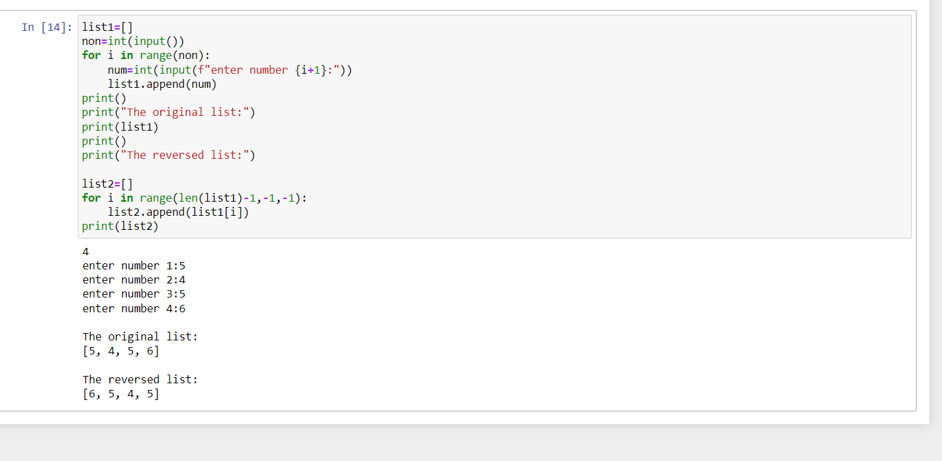

b). numbers=[]

non=int(input())

for i in range(non):

num=int(input(f"enter number {i+1}:"))

numbers.append(num)

print("User-Input List:")

print(numbers)

if len(numbers)>0:

highest=numbers[0]

for num in numbers:

if num>highest:

highest=num

print(f"the highest number from list is:{highest}")

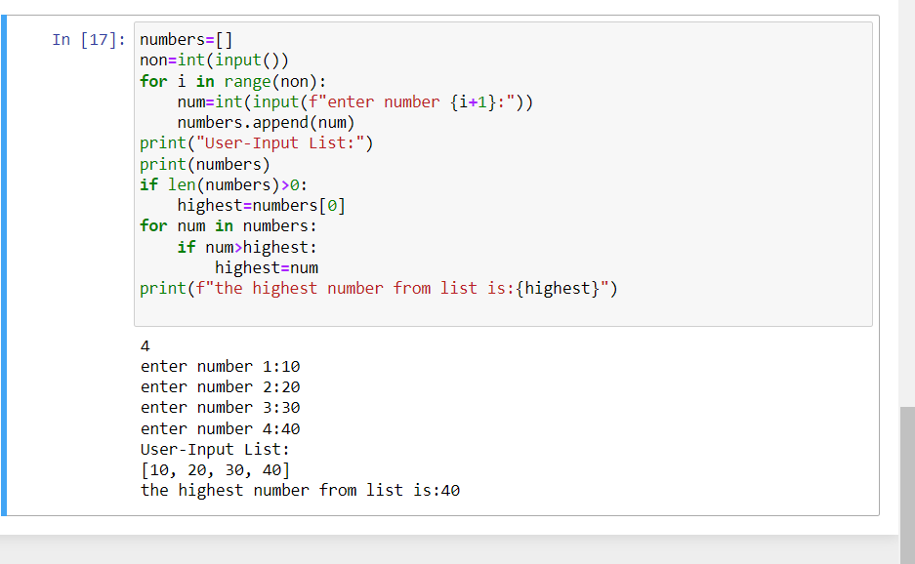

|  |  |
| --- | --- |
| 7. | Find the sum of each row of matrix of size m x n. For example, for the following matrix output will be like this:    Sum of row 1 = 32  Sum of row 2 = 31  Sum of row 3 = 63 |

Solution: n = int(input("Enter the number of rows:"))

m = int(input("Enter the number of columns:"))

matrix = []

print("Enter values in matrix :")

# For user input

for i in range(n):

data =[]

for j in range(m):

data.append(int(input()))

matrix.append(data)

# For printing the matrix

for i in range(n):

for j in range(m):

print(matrix[i][j], end = " ")

print()

# For printing row wise sum

for i in range(n):

sum = 0

for j in range(m):

sum = sum + matrix[i][j]

print('Sum of row',i+1,':',sum)

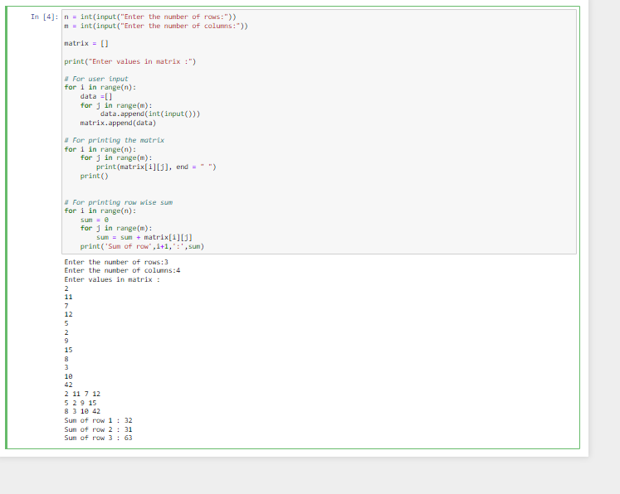

|  |  |
| --- | --- |
| 8. | a) Write a program that reads a string from keyboard and display:  * The number of uppercase letters in the string.  * The number of lowercase letters in the string.  * The number of digits in the string.  * The number of whitespace characters in the string.  b) [Python Program to Find Common Characters in Two Strings](https://www.sanfoundry.com/python-program-check-common-letters-string/).  c) [Python Program to Count the Number of Vowels in a String](https://www.sanfoundry.com/python-program-count-number-vowels-string/). |

Solution: a). text = input('Enter a string: ')

lower = upper = digit = space = 0

for ch in text:

if ch.isupper():

upper += 1

elif ch.islower():

lower += 1

elif ch.isdigit():

digit += 1

elif ch == ' ':

space += 1

print('The number of uppercase letters:', upper)

print('The number of lowercase letters:', lower)

print('The number of digits:', digit)

print('The number of whitespace characters:', space)

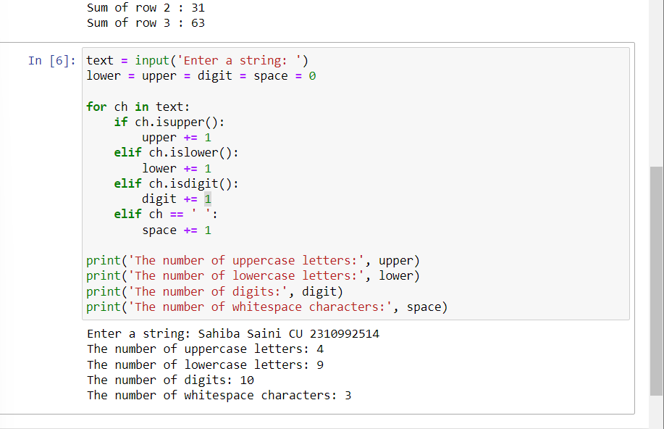

b). str1 = input()

str2 = input()

print("Original strings:")

print(str1)

print(str2)

res = ""

for ch in str1:

if ch in str2 and not ch in res:

res += ch

print("Intersection of two said String:",res)

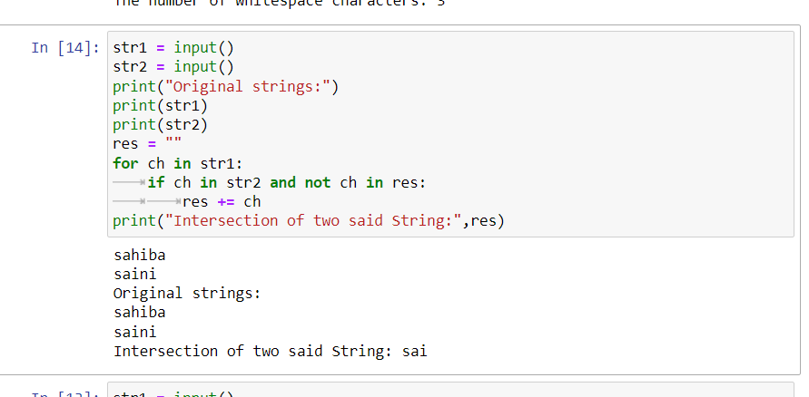

c). string=input("Enter string:")

vowels=0

for i in string:

if(i=='a' or i=='e' or i=='i' or i=='o' or i=='u' or i=='A' or i=='E' or i=='I' or i=='O' or i=='U'):

vowels=vowels+1

print("Number of vowels are:")

print(vowels)